GD100-01 Inverter for PV Pump
Product introduction:
Positioned in environmental-friendly and economical PV market, the product is applicable to PV pump system, replaces water storage with electric storage and needs no battery modules. The direct current generated by solar modules is input to the inverter and then converted into the alternating current to drive various pumps directly. Additionally, the output frequency is adjustable in real time according to sunlight intensity change.
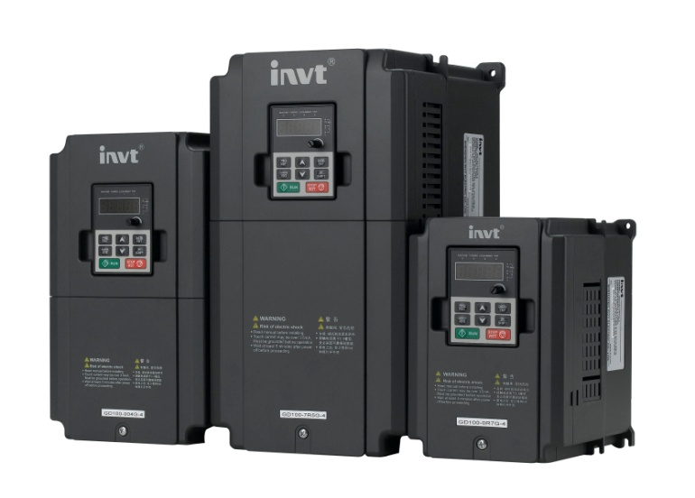

Product features:
- Maximizing power generation efficiency of solar modules with the use of advanced MPPT control technology
- Adjusting water outflow of pumps quickly on basis of sunlight intensity change
- Automatic hibernation and wakeup
- Hibernate at high water level and wake up at low water level
- Hibernate at sunrise and sunset and wake up at strong sunlight
- Underload protection and fault protection of water level sensor avoiding pumping off after water supply dries up
- TI DSP technology and Infineon PIM design, with functions of overcurrent, overvoltage and overtemperature protection, built-in C3 filter, achieving reliable, automatic and unattended running

Application:
Mainly applied to industries of agriculture and forestry irrigation, desert control, grassland animal husbandry and municipal water

Specifications:
- Parameters
Max input DC voltage | 800VDC
Recommended MPPT voltage range | 350~750VDC
Recommended input voltage | 513VDC
MPPT efficiency | 99.9%
Input channel | 1
Rated output voltage | 3-phase 380VAC
Output frequency range | 0~60Hz
Max efficiency of the machine | 97％
Ambient temperature range | (G-type inverter with water pump)
Cooling method | Air cooling
Protection degree | IP20
Altitude | Below 1000m; above 1000m, derate 1% for every additional 100m.
Standard | CE

- Power degree
Inverter model | Max DC input current (A) | Rated output current (A) | Applicable water pump (kW)
GD100-01-0R7G-4 | 4.2 | 2.5 | 0.75
GD100-01-1R5G-4 | 6.1 | 3.7 | 1.5
GD100-01-2R2G-4 | 7.1 | 5 | 2.2
GD100-01-004G-4 | 16.5 | 9.5 | 4
GD100-01-5R5G-4 | 23.9 | 14 | 5.5
GD100-01-7R5G-4 | 30.6 | 18.5 | 7.5
GD100-01-011G-4 | 39.2 | 25 | 11
GD100-01-015G-4 | 49.0 | 32 | 15

Note: When the output voltage is 380V, the output current will be the rated value; when the output voltage is at 400V, 415V or 440V, the output current will be calculated according to power.

- Recommended solar array configuration

Inverter model | Max DC input current | Open-circuit voltage degree of solar module
Inverter model | Max DC input current | 20±3V |  | 30±3V |  | 36±3V |  |  |  | 42±3V
Inverter model | (A) | Module power±5Wp | Modules per string  *strings | Module power±5Wp | Modules per string  *strings | Module power±5Wp | Modules per string  *strings | Module power±5Wp | Modules per string  *strings | Module power±5Wp | Modules per string  *strings | Module power±5Wp | Modules per string  *strings
GD100-01-0R7G-4 | 4.2 | 35 | 24*1 | - | - | - | - | - | - | - | - | - | -
GD100-01-1R5G-4 | 6.1 | 60 | 24*1 | - | - | - | - | - | - | - | - | - | -
GD100-01-2R2G-4 | 7.1 | 90 | 24*1 | - | - | 155 | 14*1 | - | - | 180 | 12*1 | - | -
GD100-01-004G-4 | 16.5 | 85 | 24*2 | 220 | 18*1 | 140 | 14*2 | - | - | 170 | 12*2 | - | -
GD100-01-5R5G-4 | 23.9 | - | - | - | - | 195 | 14*2 | - | - | 240 | 12*2 | - | -
GD100-01-7R5G-4 | 30.6 | - | - | 210 | 18*2 | 175 | 14*3 | - | - | 205 | 12*3 | 310 | 12*2
GD100-01-011G-4 | 39.2 | - | - | 205 | 18*3 | 195 | 14*4 | - | - | 235 | 12*3 | - | -
GD100-01-015G-4 | 49 | - | - | 210 | 18*4 | 175 | 14*6 | 215 | 14*5 | 250 | 12*5 | 310 | 12*4

- Dimension
Wall mounting manner

Power | W1 | W2 | H1 | H2 | D1 | Hole size
0.75kW~2.2kW | 126.0 | 115.0 | 186.0 | 175.0 | 155.0 | 5
4kW~5.5kW | 146.0 | 131.0 | 256.0 | 243.5 | 167.0 | 6
7.5kW~15kW | 170.0 | 151.0 | 320.0 | 303.5 | 196.3 | 6

